Types OF FrameWork

1. What id Data driven Framework

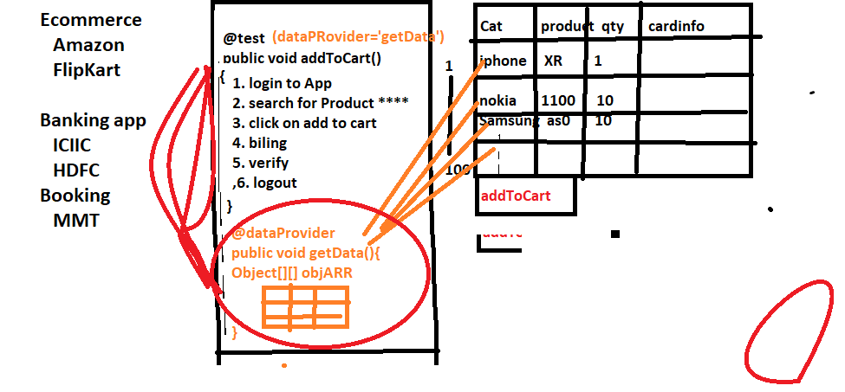

Whenever we need to test the application with huge set of data , we go for data driven framework

In data driven framework every test will have dedicated @dataProvider annotation & will have separate excel sheet for every test

@dataProvider

When ever need to execute same test with different set of data we go for dataprovider annotation

1. What is modular driven framework

When ever application is huge / contains lots of module we prefer modular driven framework

In modular driven framework , all framework components will maintain in module wise

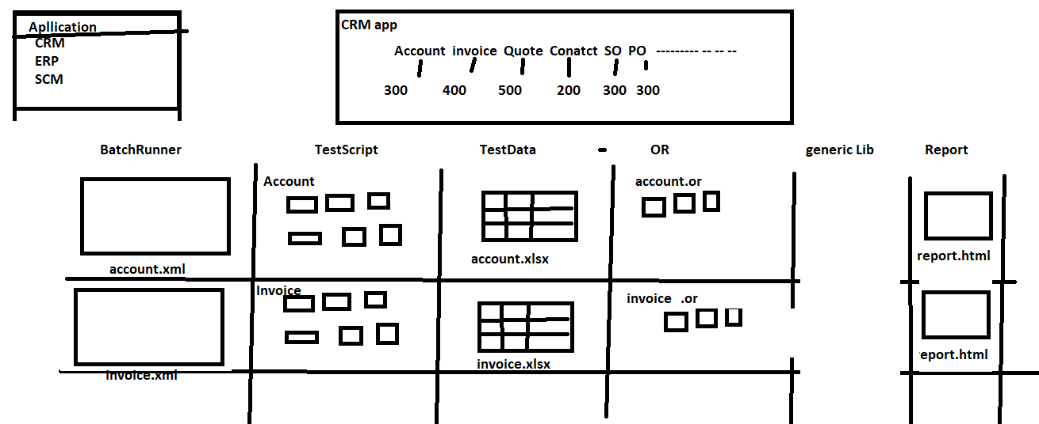

1. What is KeyWord driven Framework

When manual test Engineer want to write Automation test script With less knowledge on automation tool & without knowledge coding we for keyword Driven framework

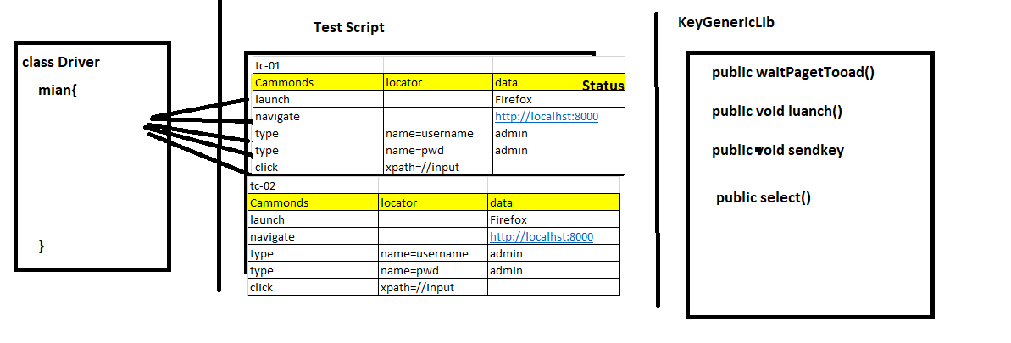

14 Hybrid driven framework

Combination of more than one framework is called hybrid driven framework

EG : the framework which we designed is hybrid because its combination of data driven + Modular driven + kewordword driven framework

**BDD Framework**

